**Pairwise TS events**

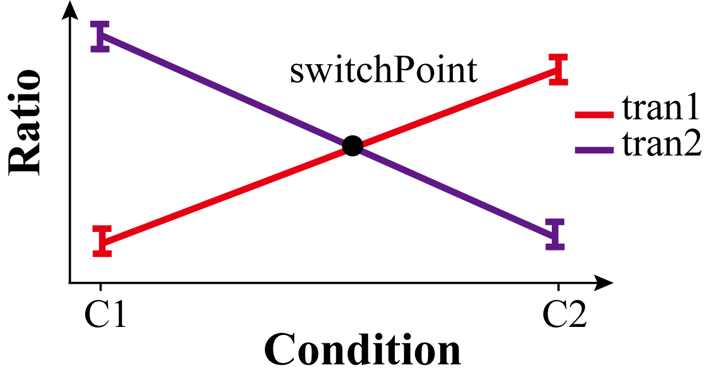

The schematic displays a pairwise TS event intuitively, C1 and C2 represent two different conditions, respectively. The y-axis (**Ratio**) in Figure S1 represents relative abundance of a transcript in the specific condition (e.g. the expression of transcript A divided by the sum of all transcript expression in a gene).

To help users to select TS events with specific patterns, deepTS provided five parameters which are described as below:

**meanRa** represents the average **Ratio** of a transcript across NC biological replicates under condition C,

$$meanRa=\frac{sum({Ratio}_{tran}|C)}{N_{c}}$$

Where **RatiotranC** represents **Ratios** of N biological replicates under condition C, NC is the number of biological replicates under condition C.

**meanExp** is similar to **meanRa**, which represents the average expression abundance of a transcript across NC biological replicates under condition C, the formula is as follows:

$$meanExp=\frac{sum({Exp}_{tran}|C)}{N_{c}}$$

Here, **Exptran|C** is the expression abundance of the transcript “tran” in NC biological replicates under condition C. TS events can be further filtered using the following four parameters.

**Filtered parameters**

1. **switchPoint:** a logic value indicating whether there is a cross point between the paired ratio curves in a TS event (default: TRUE).
$${sign⁡( meanRatio}_{tran1}\left|C1-{meanRatio}_{tran2}\right|C1)≠{sign⁡( meanRatio}_{tran1}\left|C2-{meanRatio}_{tran2}\right|C2)$$

2. **max_Exp:** a numerical vector describing the maximum **meanExp** of two transcripts in a TS events (default: (1, 1)).
$$\{{max⁡( meanExp}_{tran1}\left|C1,{meanExp}_{tran1}\right|C2),{max⁡( meanExp}_{tran2}\left|C1,{meanExp}_{tran2}\right|C2)\}$$

3. **max_FC:** a numerical parameter presenting the log2 of maximum fold change of transcripts under two conditions (default: 2).
$$max⁡(\log_{2}{\frac{{meanExp}_{tran1}|C2}{mean{Exp}_{tran1}|C1}}, \log_{2}{\frac{{meanExp}_{tran2}|C2}{mean{Exp}_{tran2}|C1}})$$

4. **min_Ratiodiff:** a numerical parameter specifying the minimum **Ratio** difference of two transcripts under two conditions (default: 0.15).

$$min(\left|{meanRa}_{tran1}\left|C1-{meanRatio}_{tran2}\right|C1\right|,\left|{meanRa}_{tran1}\left|C2-{meanRa}_{tran2}\right|C2\right|)$$

**Time-series TS events**

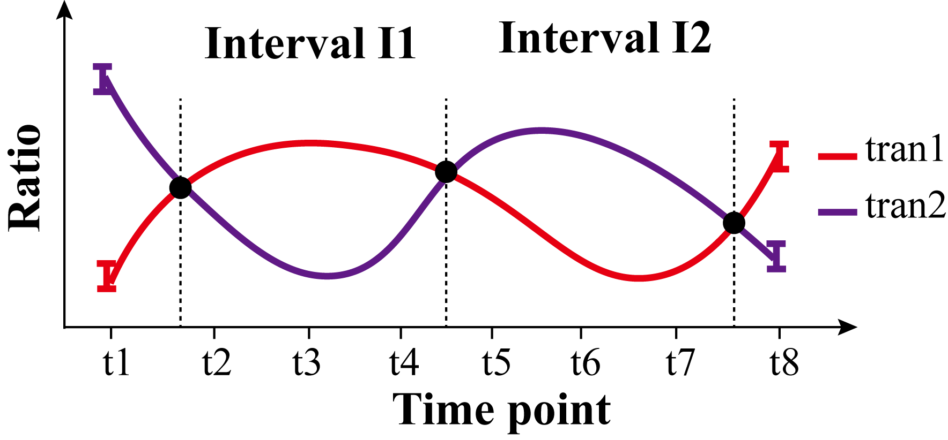

The schematic shows a time-series TS event between transcript “trans1”and “trans2”, where **Ratio** represents relative abundance for a transcript at a time point. The time series with eight time points are divided into four intervals by the intersection points of average expression. For each switch point, a series of scores are calculated and used to construct filtered metrics. For example, I1 and I2 are before and after time interval of a switch point, each contains three consecutive time points.

$$I1:\left\{t2,t3,t3\right\} I2:\{t5,t6,t7\}$$

**meanExp** is similar to **meanRa**, which represents the average Ratio of a transcript at time interval I,

$$meanRa=\frac{sum({Ratio_m}_{tran}|I)}{N_{I}}$$

Where **Ratio_mtran|I** represents the average **Ratio** of biological replicates at each time point in interval I, **NI** is the number of time points at time interval I. Similarly, **meanExp** represents the average expression abundance of a transcript at time interval I,

$$meanExp=\frac{sum({Exp_m}_{tran}|I)}{N_{I}}$$

Where **Exp_mtran|I** represents the average expression abundance of biological replicates at each time point in interval I TS events can be further filtered using the following eight parameters:

**Filtered parameters**

1. ***num***: a numerical vector describes the least number of consecutive time points in interval I1 and I2 (default: (1,1));
$$\left(N_{I1}, N_{I2}\right)$$

2. ***cor***: the Pearson’s correlation coefficient between the expression values of the paired transcripts across time courses in interval I1 and I2 (default: -0.2);
$$correlation({Ratio_m}_{tran1}|(I1+I2), {Ratio_m}_{tran2}|(I1+I2))$$

3. ***freq***: a numerical value in the range of 0–1, reflecting that the frequencies of samples of one transcript is greater than that of the other in interval I1 and is less in interval I2 (default: 0.5);
$$|P\left({Ratio_m}_{tran1}>{Ratio_m}_{tran2} | I1\right)+P({Ratio_M}_{tran1}<{Ratio_m}_{tran2}|I2)-1|$$

4. ***diff_ra***: a numerical vector describes the mean difference between two transcripts in terms of relative abundance in intervals I1 and I2 (default: (0.3, 0.3));
$$(\left({meanRa}_{tran1}-{meanRa}_{tran2}\right)\left|I1, \left({meanRa}_{tran1}-{meanRa}_{tran2}\right)\right|I2))$$

5. ***diff_pvalue***: a numerical vector describes the significance level of the difference between the relative abundances of two transcripts in intervals I1 and I2 (default: (0.05, 0.05));
$$(t.test\left({Ratio_m}_{tran1}\left|I1,{Ratio_m}_{tran2}\right|I1\right), t.test_\left({Ratio_m}_{tran1}\left|I2,{Ratio_m}_{tran2}\right|I2\right))$$

6. ***change_ra***: a numerical vector describes the difference in relative abundance of each transcript between interval I1 and I2 (default: (0.2,0.2));
$$(\left({meanRa}_{tran1}\left|I1-{meanRa}_{tran1}\right|I2\right), \left({meanRa}_{tran2}\left|I1-{meanRa}_{tran2}\right|I2\right))$$

7. ***diff_exp***: a numerical vector describes the mean difference between two transcripts in terms of expression values in intervals I1 and I2 (default: (3, 3));
$$(\left({meanExp}_{tran1}-{meanExp}_{tran2}\right)\left|I1, \left({meanExp}_{tran1}-{meanExp}_{tran2}\right)\right|I2)$$

8. ***change_exp***: a numerical vector describes the difference in average expression value of each transcript between interval I1 and I2 (default: (3,3)).

$$( \left({meanExp}_{tran1}\left|I1-{meanEXP}_{tran1}\right|I2\right), \left({meanExp}_{tran2}\left|I1-{meanExp}_{tran2}\right|I2\right) )$$

**Population TS events**

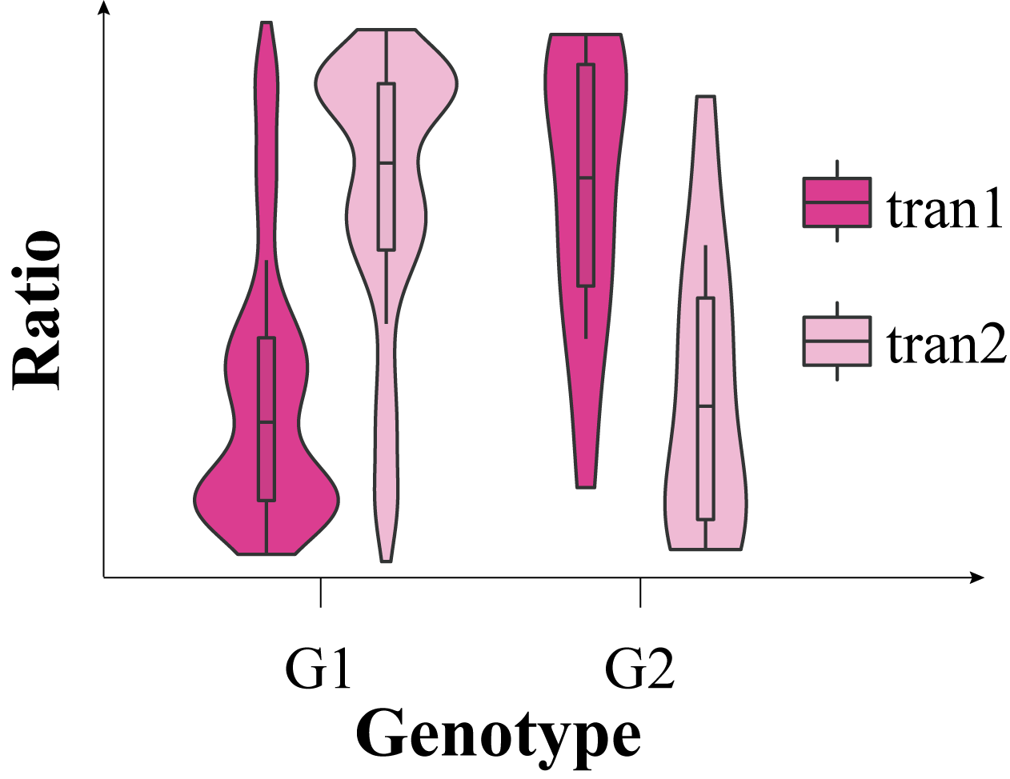

The schematic shows a sQTL associated TS event, **Ratio** represents the relative abundance of a transcript in a genotype, G1 and G2 are two different genotypes. Several parameters are defined to filter population transcriptome derived TS events. **meanRa** represents the average **Ratio** of transcript “tran with genotype G,

$$meanRa=\frac{sum({Ratio}_{tran}|G)}{N_{G}} G:\{G1,G2\}$$

Where **Ratiotran|G** is the **Ratio** of transcript “tran” in population samples with genotype G; **NG**is the number of population samples with genotype G. TS events can be further filtered using parameter **diff_Ratio,** whichis the relative difference of two transcripts between two genotypes.

$$\left({meanRa}_{tran1}-{meanRa}_{tran2}\right)\left|G1- \left({meanRa}_{tran1}-{meanRa}_{tran2}\right)\right|G2$$